**ASSIGNMENT - 4**

**PROBLEM STATEMENT :** Create a private Bucket. Upload a file and check by reassigning URL whether you can access the file or not.

**To create Private Bucket -**

**STEP 1**- Click on the “S3” button.

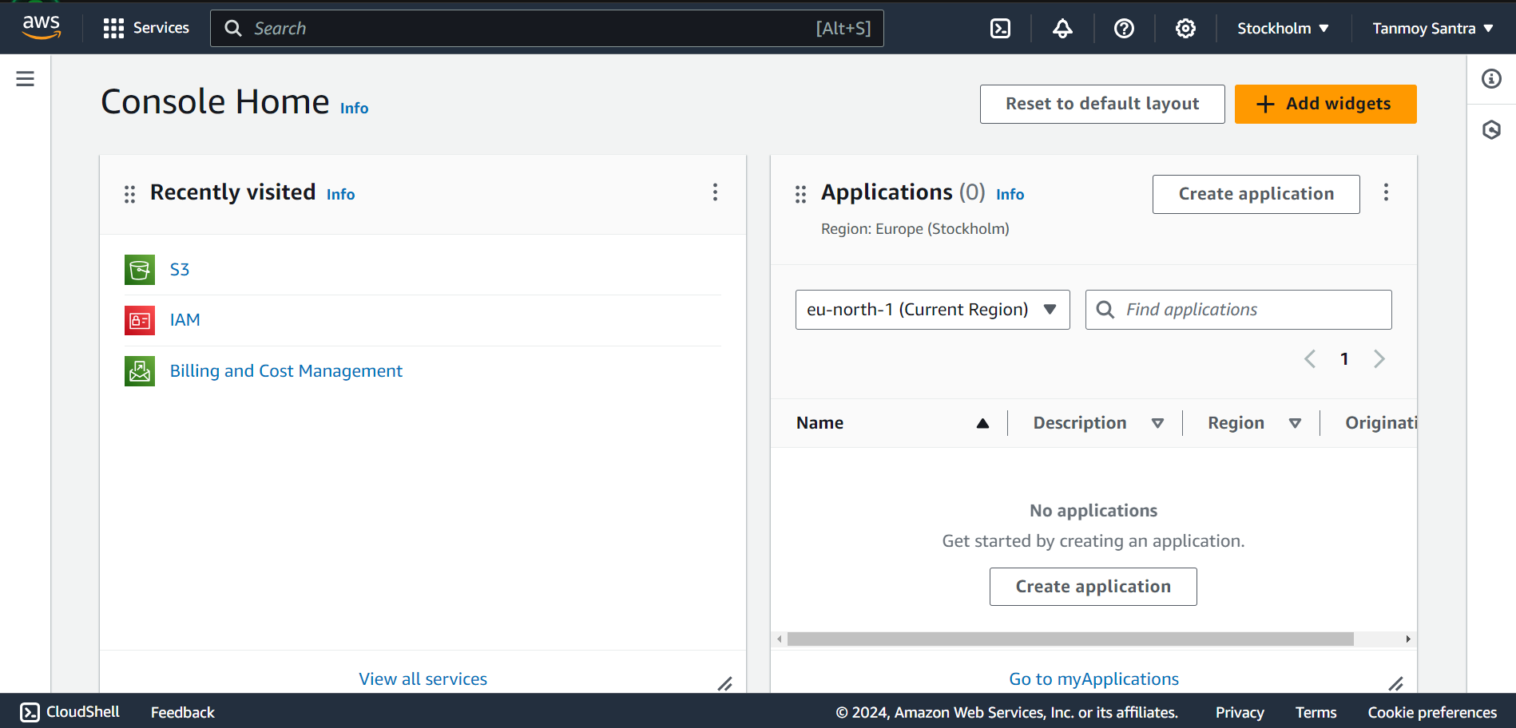

**STEP 2-** Click on “Create Bucket”.

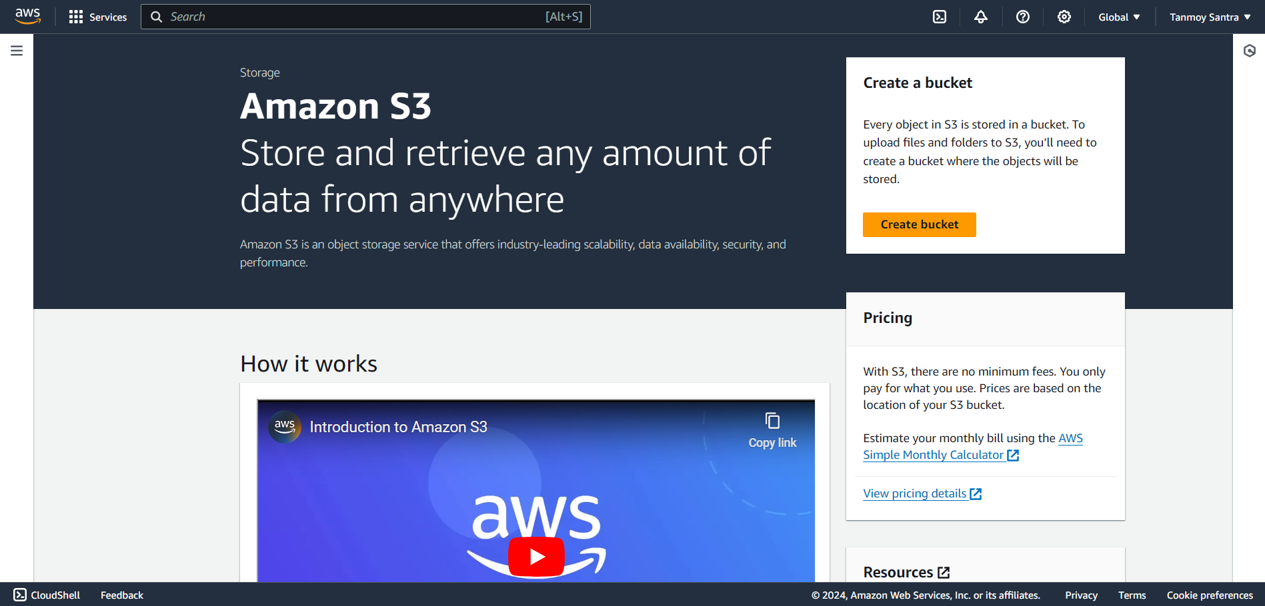

**STEP 3**- With select AWS Region “Mumbai”, give a Name to the Bucket.

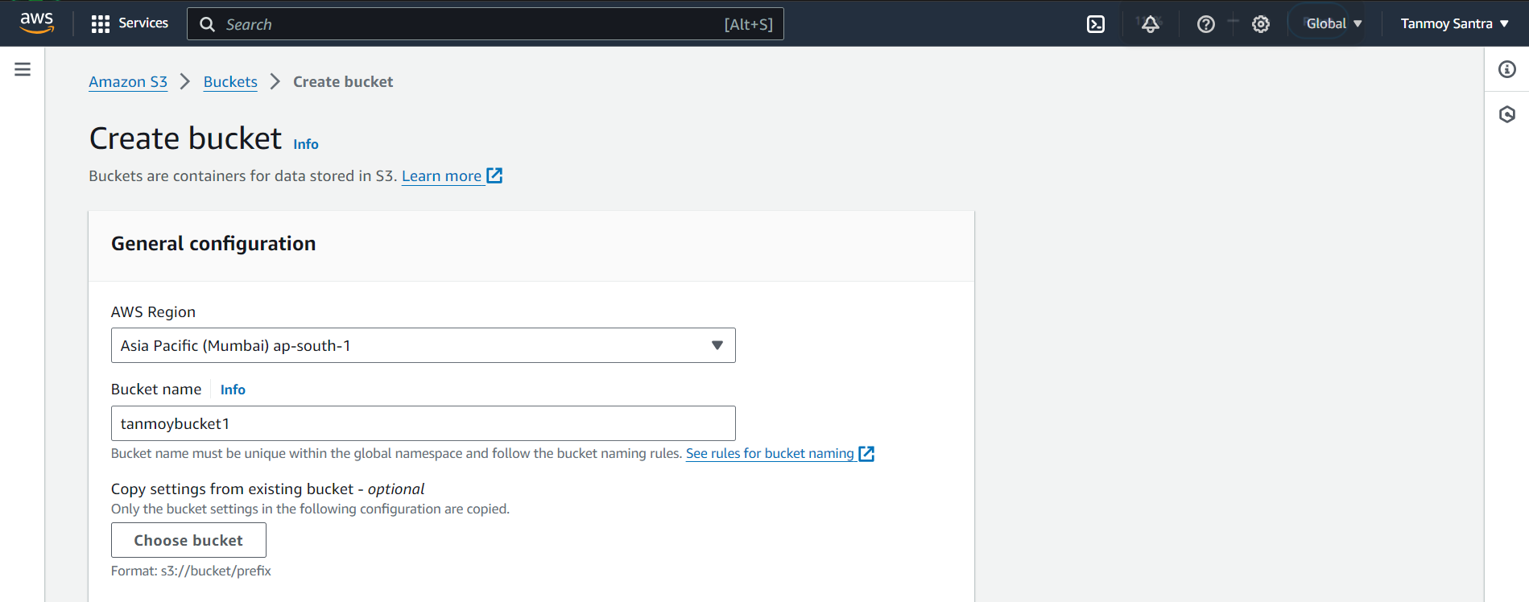

**STEP 4-** Select “ACLS disabled” & “Block all public access” checkbox. Then Click on “Create Bucket”.

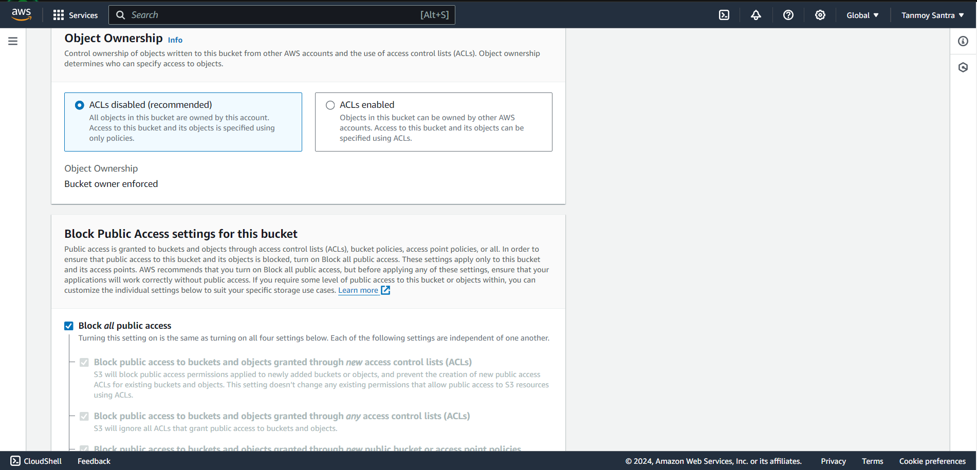

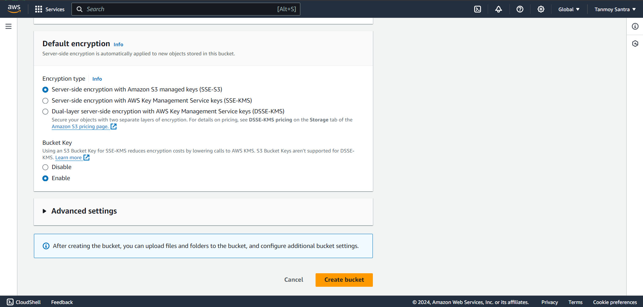

**STEP 5-** The Bucket is created. Click on the bucket name.

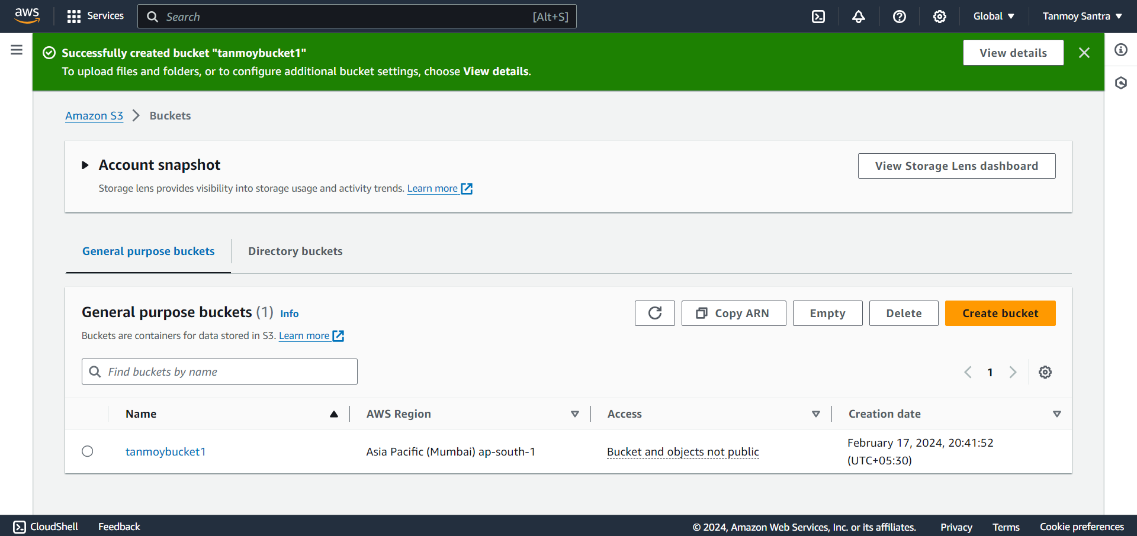

**STEP 6-** Click on the “Upload”.

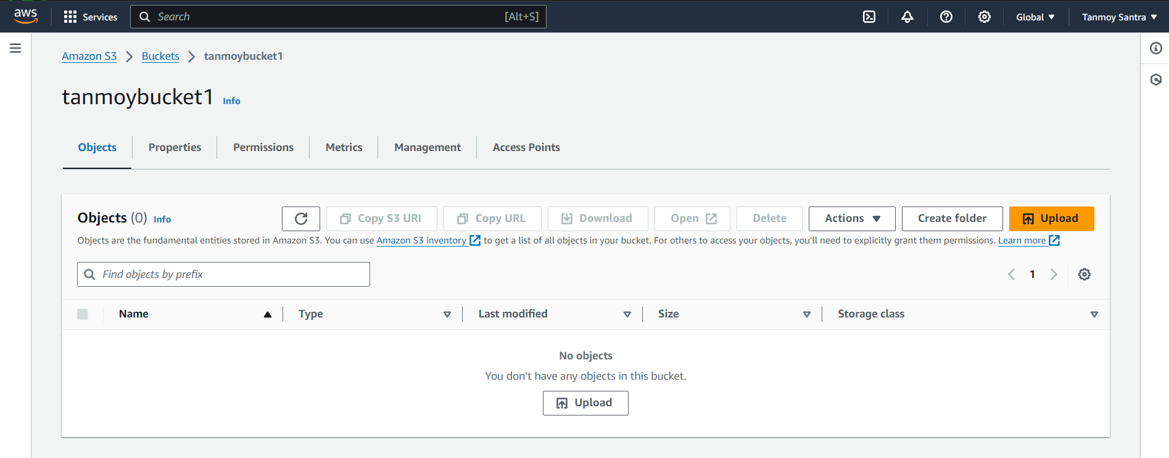

**STEP 7-** Click on “Add file” and add the files then click upload.

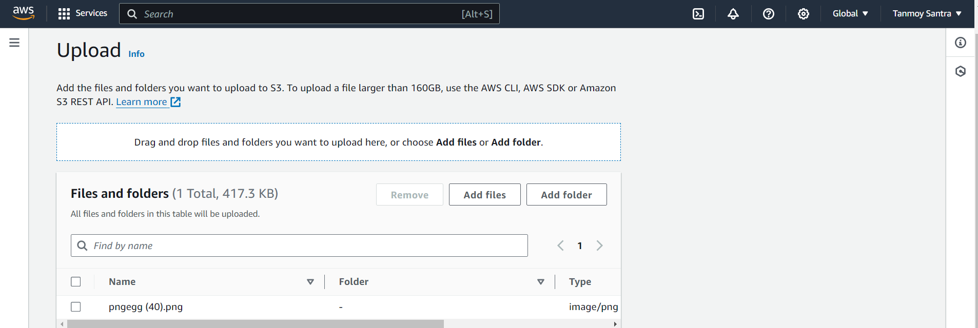

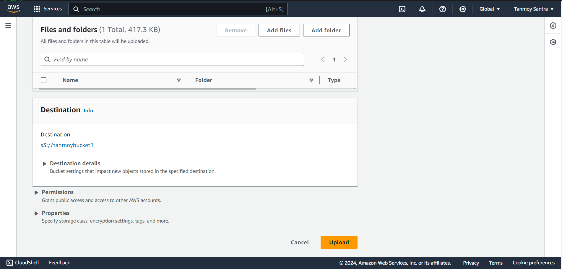

**STEP 8-** The file has been uploaded successfully. Click on the file name.

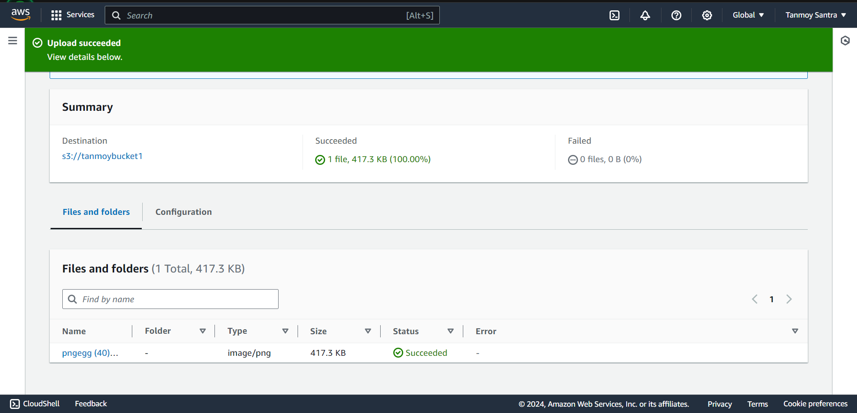

**STEP** **9-** Copy the “Object URL”.

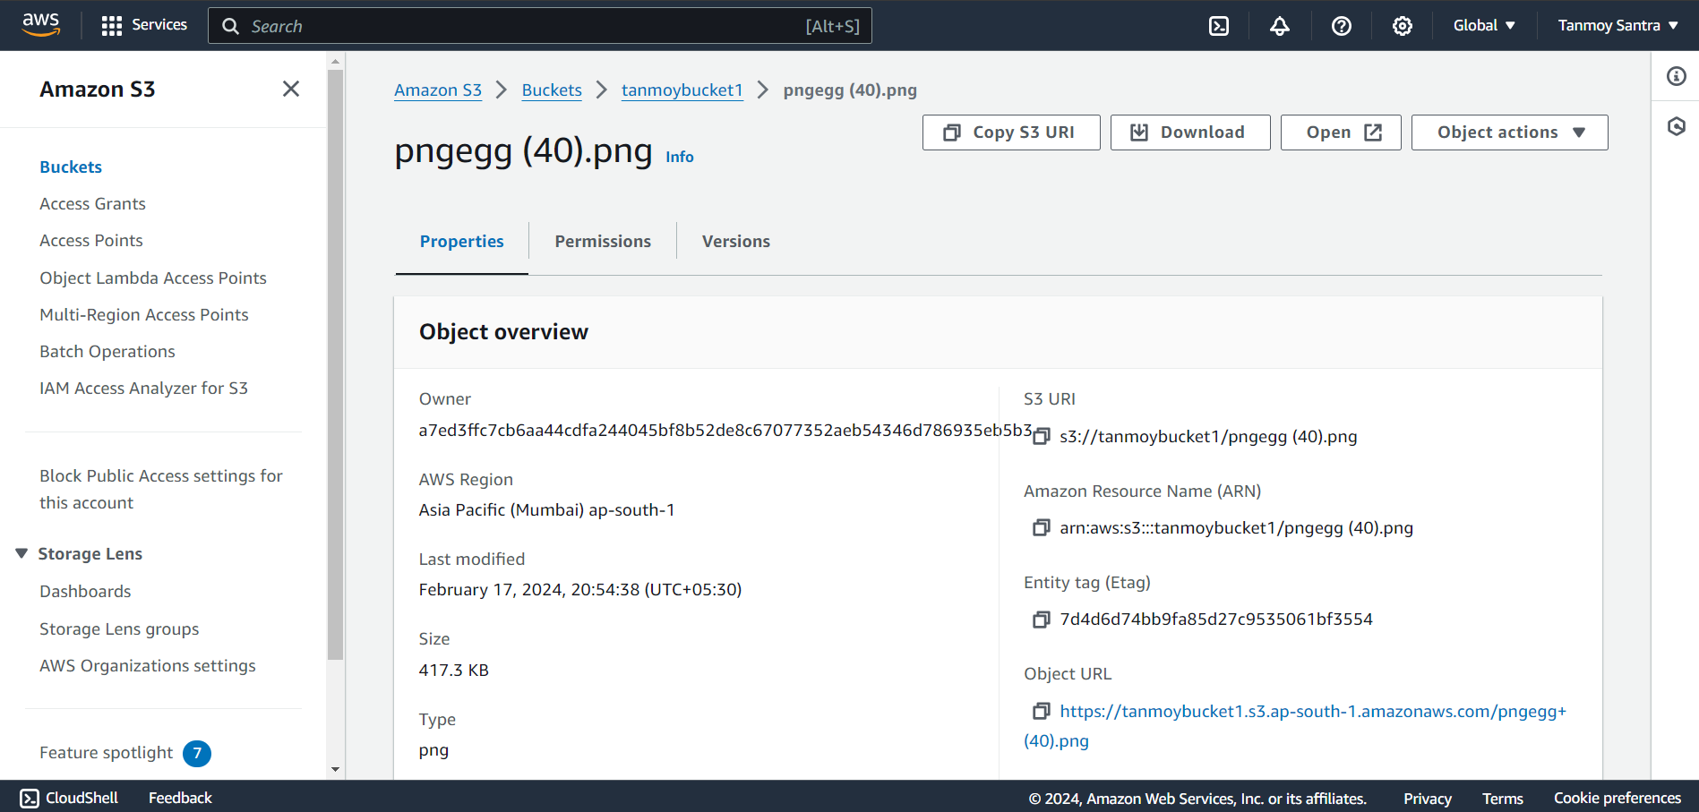

**STEP 10-** Open a new browser window and paste the URL in the address bar.

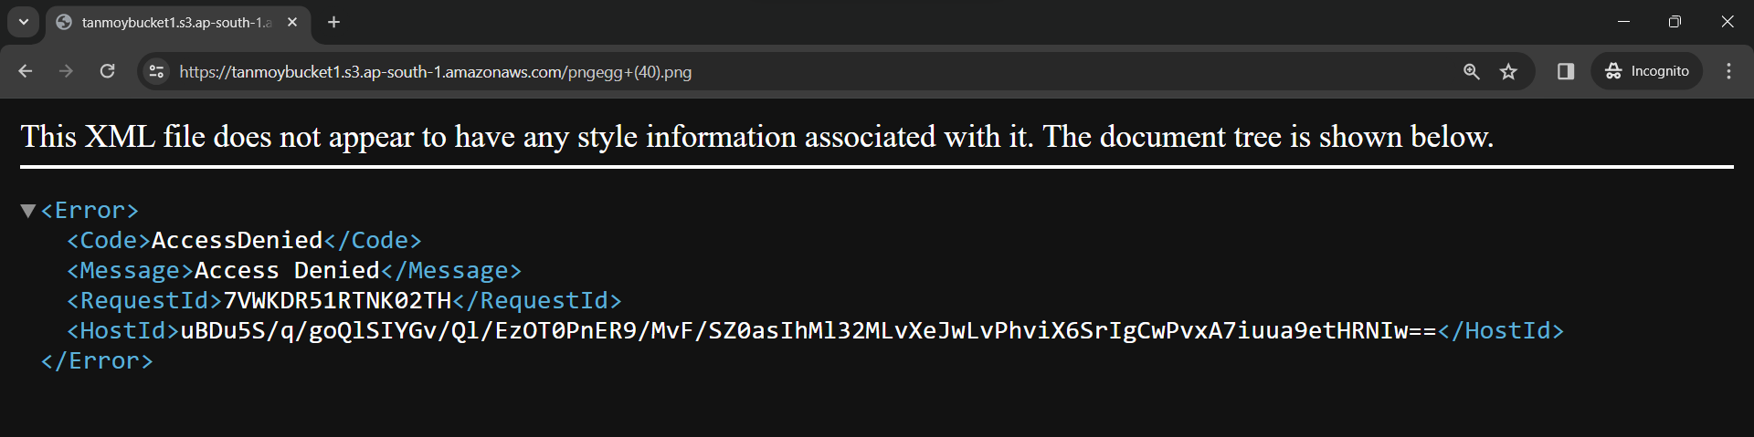

**To reassign url -**

STEP 1- Open the Bucket.

STEP 2- Select the file and Click on the “Actions” dropdown menu and select the “presigned URL”.

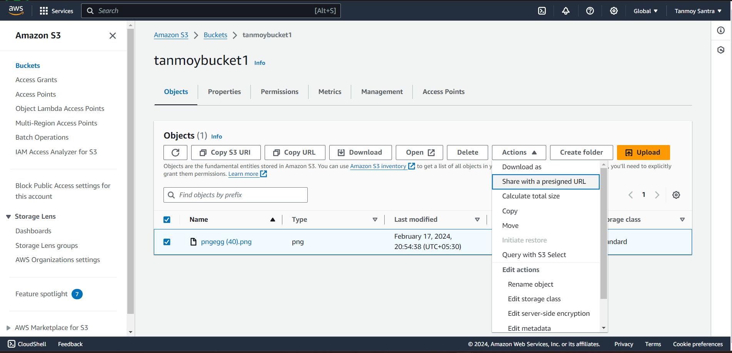

STEP 3- Give a Time limit & then click on the “Create Presigned URL” button.

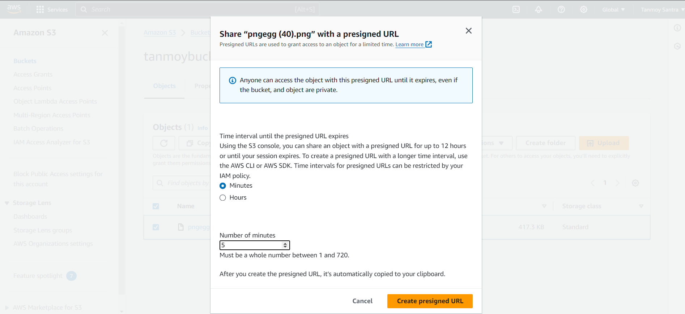

STEP 4- Copy the URL & Open a new browser window and paste the URL.

